**Azure IoT Suite with Stream Analytics**

Demo Scripts – Step by Step



Target audience: Microsoft Sellers (TSPs, SSPs) and Partners

Published: September 2016

©2016 Microsoft Corporation. All rights reserved.

By using this demo/lab, you agree to the following terms:

The technology/functionality described in this demo/lab is provided by Microsoft Corporation for purposes of obtaining your feedback and to provide you with a learning experience. You may only use the demo/lab to evaluate such technology features and functionality and provide feedback to Microsoft. You may not use it for any other purpose. You may not modify, copy, distribute, transmit, display, perform, reproduce, publish, license, create derivative works from, transfer, or sell this demo/lab or any portion thereof.

COPYING OR REPRODUCTION OF THE DEMO/LAB (OR ANY PORTION OF IT) TO ANY OTHER SERVER OR LOCATION FOR FURTHER REPRODUCTION OR REDISTRIBUTION IS EXPRESSLY PROHIBITED.

THIS DEMO/LAB PROVIDES CERTAIN SOFTWARE TECHNOLOGY/PRODUCT FEATURES AND FUNCTIONALITY, INCLUDING POTENTIAL NEW FEATURES AND CONCEPTS, IN A SIMULATED ENVIRONMENT WITHOUT COMPLEX SET-UP OR INSTALLATION FOR THE PURPOSE DESCRIBED ABOVE. THE TECHNOLOGY/CONCEPTS REPRESENTED IN THIS DEMO/LAB MAY NOT REPRESENT FULL FEATURE FUNCTIONALITY AND MAY NOT WORK THE WAY A FINAL VERSION MAY WORK. WE ALSO MAY NOT RELEASE A FINAL VERSION OF SUCH FEATURES OR CONCEPTS. YOUR EXPERIENCE WITH USING SUCH FEATURES AND FUNCITONALITY IN A PHYSICAL ENVIRONMENT MAY ALSO BE DIFFERENT.

**FEEDBACK**. If you give feedback about the technology features, functionality and/or concepts described in this demo/lab to Microsoft, you give to Microsoft, without charge, the right to use, share and commercialize your feedback in any way and for any purpose. You also give to third parties, without charge, any patent rights needed for their products, technologies and services to use or interface with any specific parts of a Microsoft software or service that includes the feedback. You may not give feedback that is subject to a license that requires Microsoft to license its software or documentation to third parties because we include your feedback in them. These rights survive this agreement.

MICROSOFT CORPORATION HEREBY DISCLAIMS ALL WARRANTIES AND CONDITIONS WITH REGARD TO THE DEMO/LAB, INCLUDING ALL WARRANTIES AND CONDITIONS OF MERCHANTABILITY, WHETHER EXPRESS, IMPLIED OR STATUTORY, FITNESS FOR A PARTICULAR PURPOSE, TITLE AND NON-INFRINGEMENT. MICROSOFT DOES NOT MAKE ANY ASSURANCES OR REPRESENTATIONS WITH REGARD TO THE ACCURACY OF THE RESULTS, OUTPUT THAT DERIVES FROM USE OF DEMO/ LAB, OR SUITABILITY OF THE INFORMATION CONTAINED IN THE DEMO/LAB FOR ANY PURPOSE.

**DISCLAIMER**

This demo/lab contains only a portion of new features and enhancements in Microsoft Azure IoT. Some of the features might change in future releases of the product. In this demo/lab, you will learn about some, but not all, new features.

# Contents

Contents 5

Demo 1 – Creating Azure Service Bus Event Hub & Streaming app in C# 6

Creating Azure Streaming Analytics Job 6

Demo 2 – Creating Vehicle Telemetry Analysis real-time streaming Solution 6

Demo 3 – Creating real-time Twitter event streaming analysis 7

Demo 4 – Building of Azure IoT Suite app – Predictive Maintaince Analytics 9

End-to-end hands-on experience – Azure Stream Analytics with AML integration app 15

Conclusion 17

# About this experience

## Goals

The document provides step by step guidance on how to build out an end-to-end stream processing solution from event ingestion to consumption via a live dashboard with automated alerting. Learn how to express your stream processing logic in a SQL-like language with built in temporal semantics and how to call out to a machine learning model to perform anomaly detection, classification, and other predictive analytics in real time with Azure IoT suite & Microsoft Data Analytics platform with real-world scenarios.

## Products and Technologies Showcased

* Microsoft Azure IoT Suite
* Azure Service Bus Event Hub
* Azure Stream Analytics
* PowerBI
* Azure Machine Learning
* Cortana Intelligence Suite

# Creating Azure Service Bus Event Hub & Streaming App in C#

| Narrative | Click Step | Screenshot |
| --- | --- | --- |
| * Demo to show how to create Azure Service Bus Event Hub | 1. Open Microsoft Edge (or Internet Explorer) on your machine. 2. Navigate to Azure Classic Portal URL: <https://manage.windowsazure.com> 3. Or Open New Azure Portal   <https://portal.azure.com>   1. Click New -> Data & Analytics & select ‘Event Hub’ to provision. 2. Provide a suitable name of the ‘Event hub’ & choose a region & monitoring storage account. 3. Next, it’ll start provisioning Azure Service Bus Event Hub |  |
| * Create Event Hub Streaming App in C# | 1. Open the Event Hub Streaming Sample apps in C# from [this link](https://github.com/Azure/azure-stream-analytics/tree/master/Samples) in GitHub. |  |
| * Create Azure Stream Analytics Job | 1. Open <https://manage.windowsazure.com> & click on ‘New’ -> ‘Data Services’ -> ‘Stream Analytics’ -> Quick Create -> provide ‘Job name’, select ‘region’ & provide regional storage account name. |  |
| 2. Demo 2:  **Creating Vehicle Telemetry Analysis real-time streaming Solution.** | 1. Download the Vehicle telemetry app sample from this link in GitHub.   <http://go.microsoft.com/fwlink/?LinkId=717075>   1. Run the app in Visual Studio & replace the Event Hub Connection String in app.config. 2. Add the Event Hub connection as input as ‘Data Stream’ to the Stream Analytics job & provide a suitable output of the job (e.g. PowerBI Output connector) 3. Also, add the VINRefData.csv file into the Azure Blob storage & add the credential as the input ‘Referenece data’ stream. 4. Add the following ASA-SQL query before starting the job.   select input.vin, blobsource.Model,input.timestamp, input.outsideTemperature, input.engineTemperature, input.speed, input.fuel, input.engineoil, input.tirepressure, input.odometer, input.city, input.accelerator_pedal_position, input.parking_brake_status, input.headlamp_status, input.brake_pedal_status, input.transmission_gear_position, input.ignition_status, input.windshield_wiper_status, input.abs into output from input join blobsource on input.vin = blobsource.VIN |  |
|  | 1. Start building the Vehicle Telemetry analysis PowerBI real-time dashboard. |  |
| **Demo 3: Creating real-time Twitter event streaming analysis** | Download the Twitter Streaming App from Github.  <https://github.com/Azure/azure-stream-analytics/tree/master/DataGenerators/TwitterClient> |  |
|  | 1. Run the streaming app in VS & connect with an Azure Event Hub as the data stream source to ASA job. 2. Create azure streaming analytics job ‘TwitterEvents’ & add the corresponding Event Hub as Input data stream to it. 3. Add PowerBI for realtime dashboard or Azure SQL database & add the following ASA-SQL query for processing data in windowing slots.   SELECT Topic,count(*) AS Count, Avg(SentimentScore) AS AvgSentiment, System.Timestamp AS Insert_Time  INTO TweetCount  FROM TwitterInput TIMESTAMP BY CreatedAt  GROUP BY TumblingWindow(second,5), Topic |  |

# Demo 4 – Building of Azure IoT Suite app – Predictive Maintenance Analytics

For a more detailed end-to-end hands-on experience of Azure IoT suite samples, follow this link.

<https://www.azureiotsuite.com/>

1. Open a new tab in your browser and navigate to URL:
2. Login with your corp. credentials & click on ‘Create a new Solution’ & start building a predictive maintenance solution analysis.

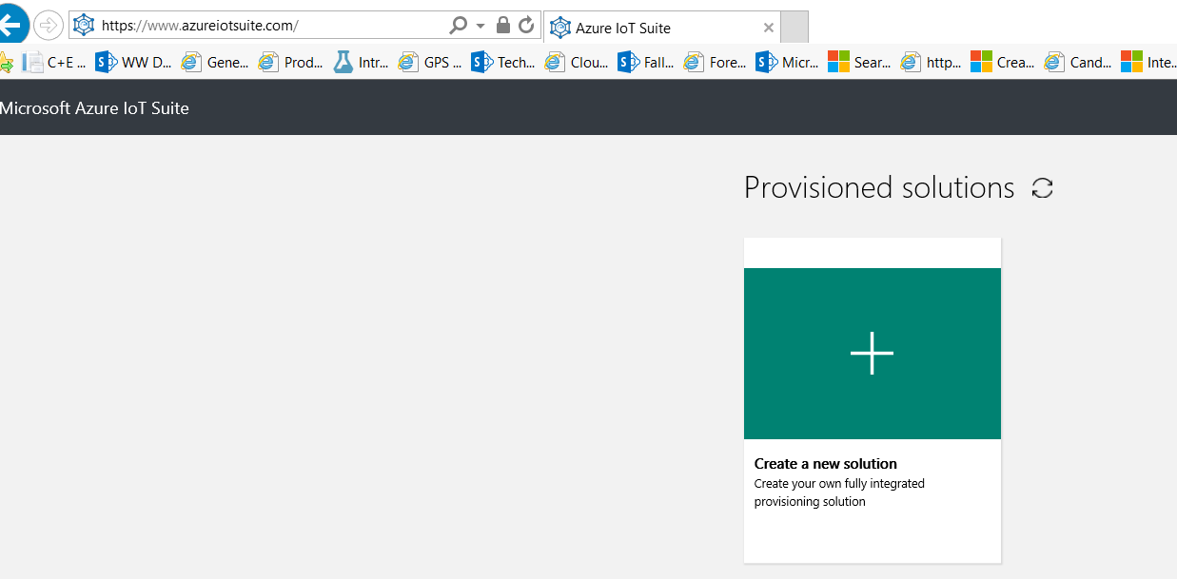

1. Click on ‘Predictive Maintaince solution’ & start provisioning the IoT solution.

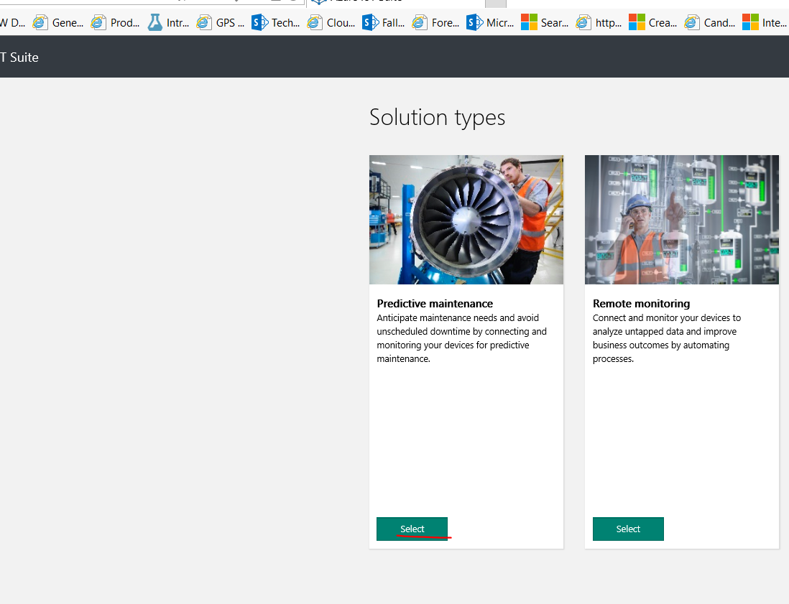

1. Provide the ‘solution name’, select the subscription name & region & click ‘Create Solution’ button.

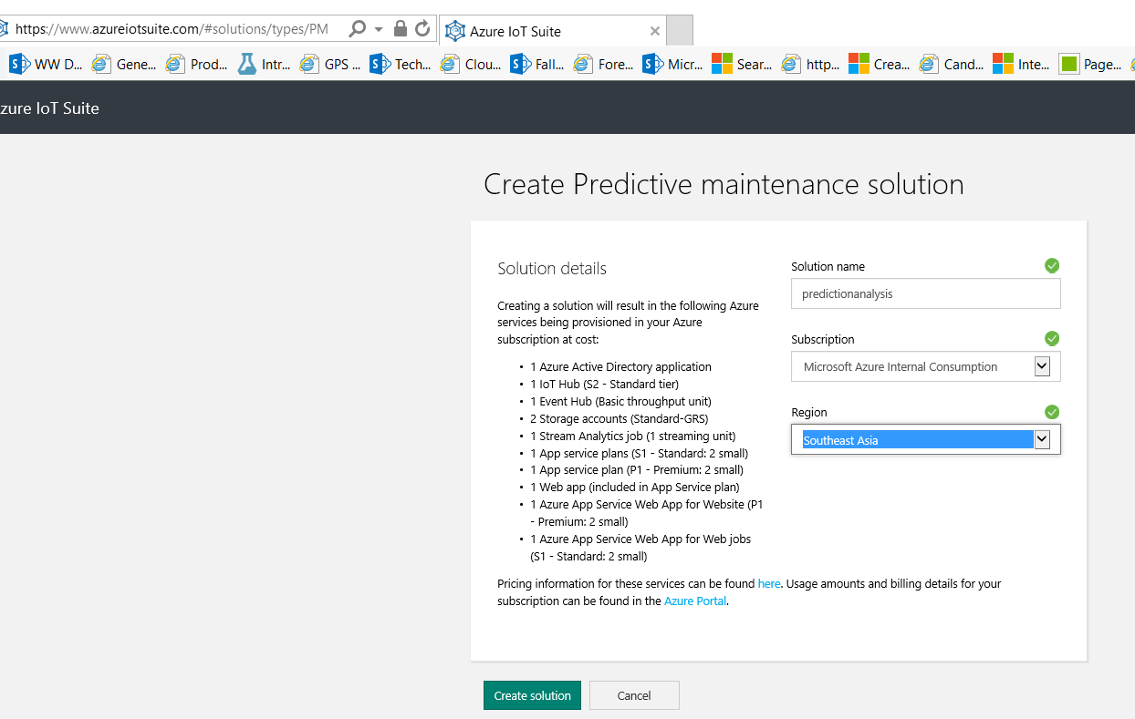

1. Once, it’s started provisioning, click on ‘Details’ tab to check the various connected Azure IoT components(e.g. Event Hub, Stream Analytics, DocumentDB, PowerBI, Azure ML workspace, Azure Web app) started to provision.

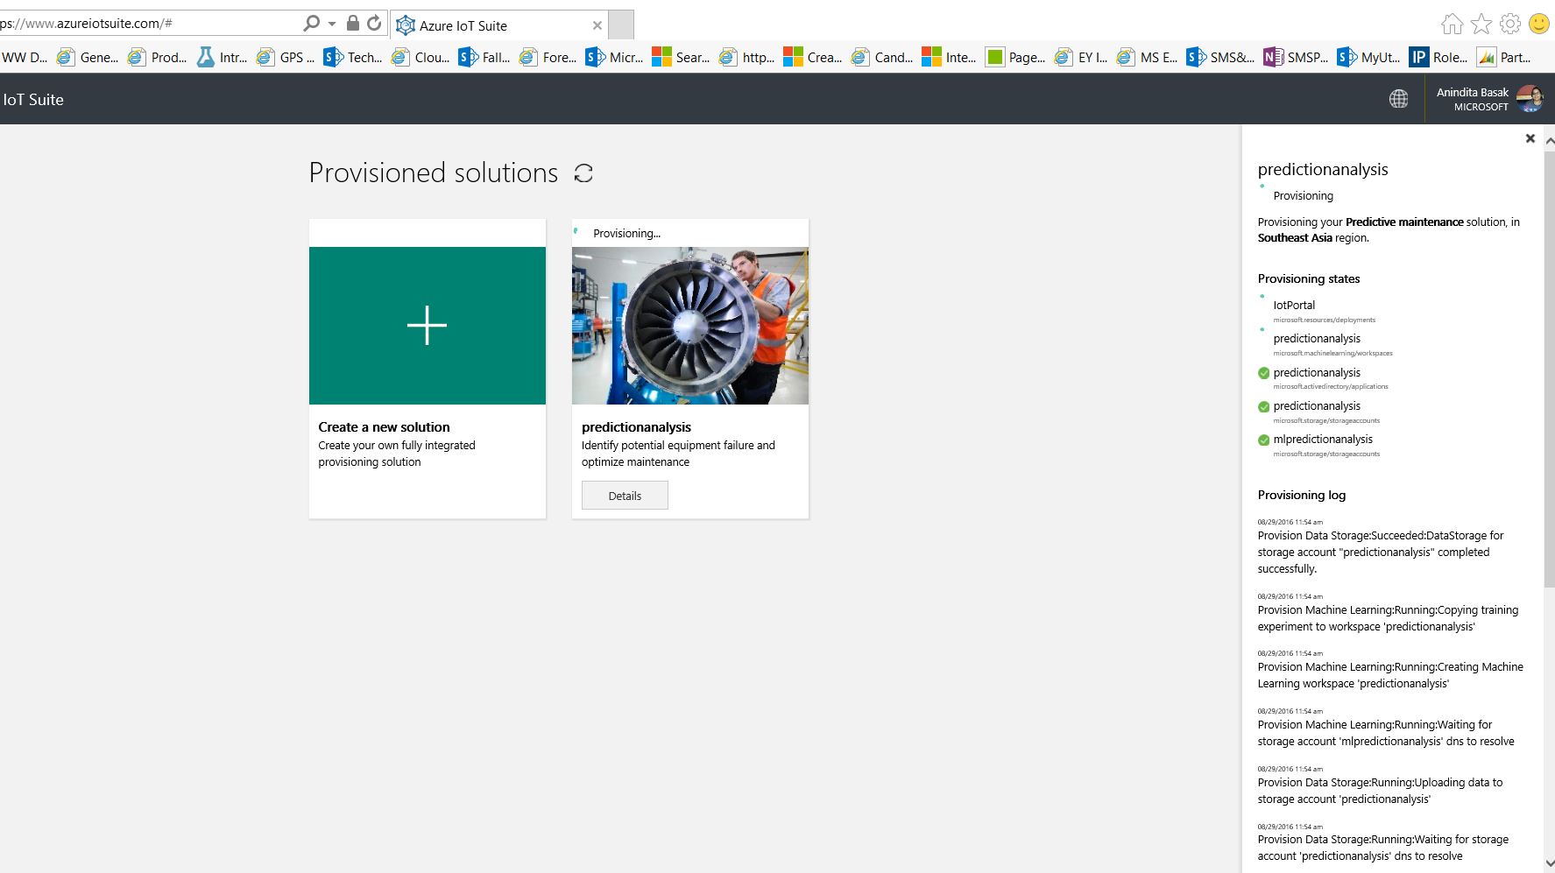

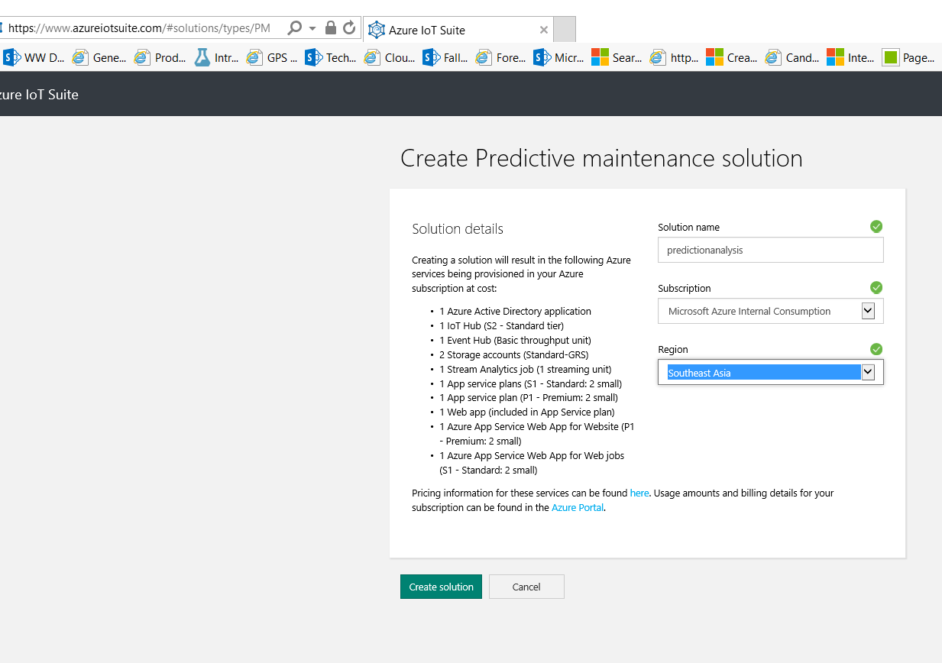

1. Once the predictive maintenance analytics solution provisioned, you can start exploring various dashboards. Click on ‘Solution Dashboard’ to view & finally click on ‘Start Simulation’ to start processing data analysis.

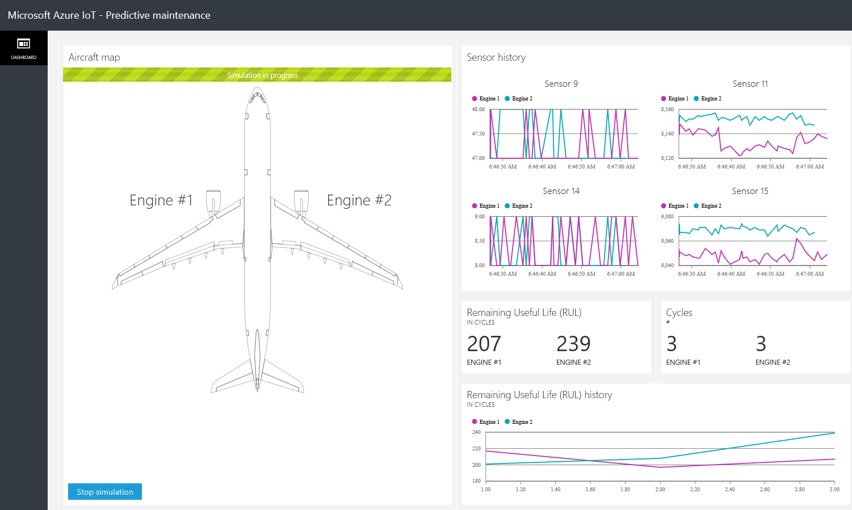

# Demo 5 – End-to-end hands-on experience – Azure Stream Analytics with AML integration app

1. The demo follows the following solution architecture diagram:

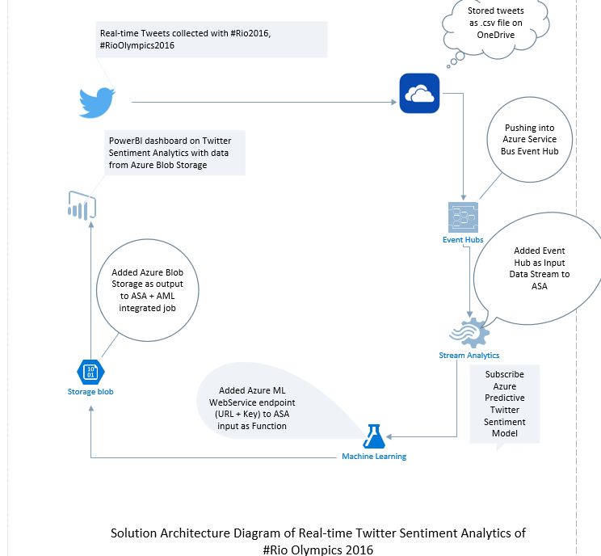

1. Follow the steps & code from [this msdn blog link](https://blogs.msdn.microsoft.com/anindita9/2016/08/14/rioolympics2016-twitter-sentiment-analytics-using-azure-stream-analytics-azure-ml-with-predictive-analytics-using-powerbi/) to start building Azure Stream Analytics with Azure ML integration predictive analytics solution & implement real-time twitter sentiment analytics.

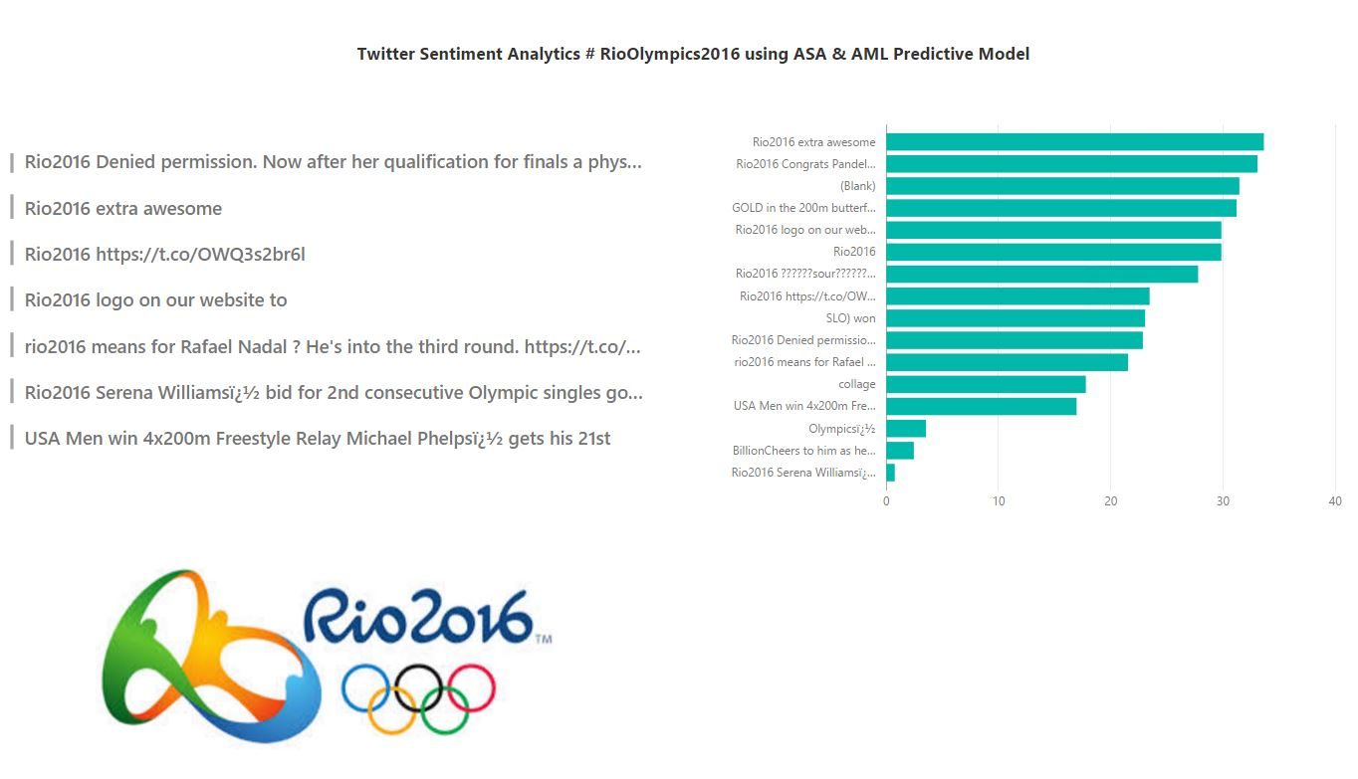

# Conclusion

In this demos, we tried to explore the various real-world solutions/PoC which can be applied to Azure IoT scenarios.

Thank you, and we hope you enjoyed this experience!